**Technisch ontwerp Fischer Technik**

**Project: Fischer Technik**

**Opdrachtgever: Fischer Technik**

**Projectnummer: N.V.T.**

**Auteur: Jesse Siersema**

**Datum: 26-4-2018**

**Versie: N.V.T.**

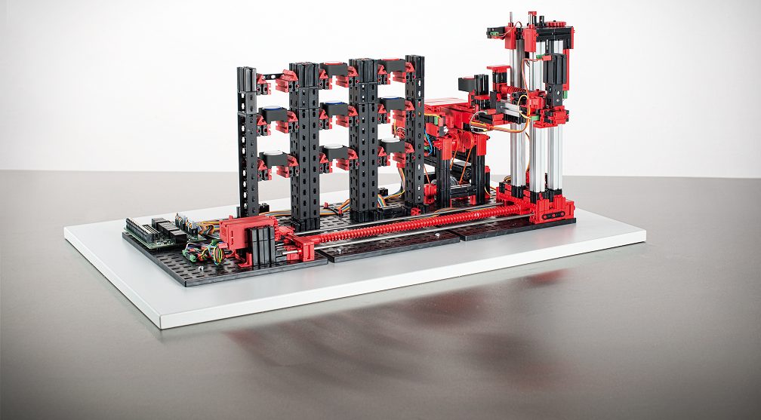

Ondergetekenden verklaren zich akkoord met de inhoud van dit technisch ontwerp.

**Opdrachtgever Projectmanager**

***Paraaf gezien: Paraaf gezien:***

Datum: <Geef de datum op.> Datum: <Geef de datum op.>

Plaats: <Geef de plaats op.> Plaats: <Geef de plaats op.>

Inhoudsopgave

Inleiding 3

Technische Eisen 3

Componenten en modules 3

Diagrammen 3

Klassen diagram 3

Activiteiten diagram 3

Sequentie diagram 3

Beslissingen 3

Afspraken 3

Grenzen 4

Plan van Aanpak 4

Haalbaarheidsstappen 4

Test plan 4

Over dit document 4

Afkortingen 4

Referenties 4

Definities 4

Gebruikte materialen 5

BIJLAGEN 5

BIJLAGE B Accordering 6

# Inleiding

In this Document you will find some information about the Technical aspect of this project.  
We will describe what we are going to use like Components and modules, The Diagrams of how this is going to work and how we are going to test this

# Technical Requirements

The Warehouse should pick up the boxes, then put the box on the conveyor belt and let the conveyor belt roll forward.  
If possible the user should also be able to put the box back on the conveyor belt and let the Warehouse arm put the box back sorted on color OR where the box originaly came from.  
This Proccess shouldn’t take more than 1 or 2 minutes  
If there is any time left we are going to make a website with which you can control the Warehouse.  
We’re going to code in C++ or C depending on which one is easier.

# Components and Modules

This project Consists of a Hihg Bay Warehouse 24 Volts from Fischer Technik and a Controllino Mega.  
The Warehouse will be Controlled With the Controllino Mega which then will connect to the Computer Either over an Ethernet Cable

# Diagrams

Please Refer to the PDF included in this file.[1]

# Plan of action

There is A Whole Document made for this, please Refer to the File in question.[2]

# Test plan

We’re going to Test this by obviously just Pressing the buttons and checking if every box is able to be picked up, if the machine can recognize the colors and if it can see if it’s empty.

# Over dit document

## Gebruikte materialen

|  |  |
| --- | --- |
| Onderdeel | Omschrijving |
| Controllino Mega | An arduino mega in an enclosure. |
| High Bay Warehouse 24 Volt | The Constructon itself which we are going to work with that already includes all the parts we need. |

# Attachments

BIJLAGE B Accordering 6

|  |  |  |  |  |
| --- | --- | --- | --- | --- |
|  | **Acceptatiepunt** | **Akkoord** | | **Opmerkingen** |
|  |  | **wel** | **niet** |  |
|  | Agrees with the plans made |  |  | <Geef opmerkingen.> |

**Overige opmerking:**

|  |
| --- |
| <Geef eventueel opmerkingen.> |
|  |

|  |  |  |  |  |
| --- | --- | --- | --- | --- |
| Gezien namens: |  |  | Paraaf gezien: | Datum gezien: |
| Projectmanager | : | <Geef de eigen bedrijfsnaam op.> |  | <Geef de datum op.> |
| Opdrachtgever | : | <Geef de bedrijfsnaam van de opdrachtgever op.> |  | <Geef de datum op.> |

BIJLAGE B Accordering

File 1: FlowchartDDC.PDF

File 2: Plan-of-Action-FischerTechnik.docx

1. See the Attachments part of this Document.
2. See the Attachments part of this Document